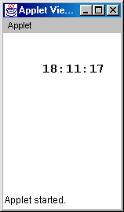

// program to display a digital clock allowing the calculation of
// the time and displaying the value to run in its own thread of
// execution

import java.applet.*;
import java.awt.*;
import java.util.*;
public class ThreadApplet extends Applet implements Runnable
{
Thread appletThread;
Font font = new Font("Monospaced",Font.BOLD,16);
int hours, mins, secs;

// override the init() method to initialize and start
// a thread of execution
public void init()
{
if (appletThread == null)
{
appletThread = new Thread(this);
appletThread.start(); // start from class Thread
}
}

// calculate the time of day, and call the repaint method to
// display the time
public void run() // implemented from the interface Runnable
{
while (true)
{
GregorianCalendar time= new GregorianCalendar();

hours = time.get(Calendar.HOUR_OF_DAY);
mins = time.get(Calendar.MINUTE);
secs = time.get(Calendar.SECOND);

repaint();

// generate a short pause by letting the thread sleep
try{Thread.sleep(1000);}
catch(InterruptedException i){System.exit(1);}
}
}

// display the time in the applet's window
public void paint(Graphics g)
{
g.setFont(font);
g.drawString(String.valueOf(hours)+":"+
String.valueOf(mins)+":"+
String.valueOf(secs),50,50);
}
}

